Preparing Your Educational Leadership CV and Teaching Dossier:

Ideas, Tips and Strategies
Draft. Last updated: June 2019

Introduction to the Document 1
Ideas, Tips, and Strategies 2
Consult the Collective Agreement (CA) and the SAC Guide 2
Senior Appointments Committee 2
Who is the Audience for the CV? And Related Advice 2
Who is the Audience for the Dossier? And Related Advice 3
Special Common Concern: Something didn’t go well. How should I handle this? 4
When Career Planning for Educational Leadership, Look to the Collective Agreement and the SAC Guide 4
Appendix A: Teaching Dossier Table of Contents 6
Jonathan Verrett 7
Steven Barnes 8
Ives, Joss 9
Sally Willis-Stewart 10
Siobhàn McPhee 12
Catherine Rawn 14
Christina Hendricks 15
Sara Harris 17
David Ng 20
Sources of Information for this Document 21
Contributors 22

Introduction to the Document

This document was created primarily as a resource for UBC Educational Leadership (EL) faculty members to assist them as they create and develop their CV and Teaching Dossier. Our intention is to offer suggestions for good practice and to record questions to be addressed, and resources to develop, that will support EL faculty members in their career advancement. See end of the document for more about the sources of information used to create this document.
Use this advice with caution. Please report to Dr. Catherine Rawn (cdrawn@psych.ubc.ca) any discrepancies with the Collective Agreement or SAC Guide (and use the CA and SAC Guide instead).

Ideas, Tips, and Strategies

Consult the Collective Agreement (CA) and the SAC Guide
- The Collective Agreement is #1, and the Senior Appointments Committee (SAC) Guide is intended to help faculty prepare the relevant materials and interpret the CA.
- Collective Agreement: http://www.hr.ubc.ca/faculty-relations/collective-agreements/
- SAC Guide is linked on this page, which also has procedures: http://www.hr.ubc.ca/faculty-relations/tenure-promotion-reappointment-confirmation/tenure-promotion-reappointment-for-faculty-members/
  - Additional document specifically on Guidelines for Promotion to Professor of Teaching: http://www.hr.ubc.ca/faculty-relations/files/Guidelines-for-Promotion-to-Professor-of-Teaching.pdf
- The role of SAC is to evaluate each case in terms of the Collective Agreement and to make a recommendation to the President.
- These documents are a bit vague, which can feel stressful. But remember this is, overall, a good thing, as it allows the university to accommodate the norms and needs of Faculties, and consider individual cases.
- Ask if you do not understand something. Who can you ask? Your Department Head (make sure you meet with this person), Faculty Association, colleagues in the EL stream, etc.

Senior Appointments Committee
- This group is made up of Professors and Professors of Teaching from across the university (i.e., a highly interdisciplinary group). They review each tenure and promotion case file, and send a recommendation to the President, who has the final say. Faculty members from the EL stream who are on SAC are all at the rank of Professor of Teaching.
- SAC typically receives a portion of a candidate’s file:
  - CV (prepared by candidate)
  - Student Evaluations of Teaching (formal preparation, typically by the Faculty or School)
  - Peer Evaluations of Teaching (formal, usually part of Departmental Standing Committee process)
  - Letters from external referees
  - Departmental Standing Personnel Committee (DSPC) Vote Results
  - Letters from Department Head and Dean that address and summarize the strengths and weaknesses of the case in terms of the Collective Agreement
  - Dean’s Advisory Committee on Promotion and Tenure (DACOPAT) Vote Results

Who is the Audience for the CV? And Related Advice
- Find the most recent copy of the approved CV format in the appendices of the SAC guide. It is available for download here: http://www.hr.ubc.ca/faculty-relations/tenure-promotion-reappointment-confirmation/tenure-promotion-reappointment-for-faculty-members/
- The CV will be read by colleagues in your department, external reviewers, colleagues across your Faculty/School/Unit, SAC, and the President. It needs to stand alone.
- Add in sub-headers, as you need them. Bold and underline them so they stand out. For example, add Local, National, and International to make your different contributions stand out.
- At the top of a section in the CV (e.g., section 8), write a short narrative and tie to a theme in order to guide reader. One way to think about this is identifying your “signature contributions” or “signature features of your practice” which are then supported by the lists that come next. Use sections strategically to showcase how you view this aspect of your career.
- Add brief annotations to help make plain what your contributions have been.
- A role that has both EL and Service components, for example, can appear in both places, with cross-reference to the other (e.g., work on a Curriculum Committee (Service) that leads to Curriculum Development (Educational Leadership)).
- A simple list for Service is typically sufficient. Don't worry so much about annotating here, although you might refer readers to a corresponding EL component, or you might split out so different communities are emphasized, as appropriate.
- If listing a team project, add a brief phrase emphasizing what you have contributed.
- Help your readers by making a summary table of your Student Evaluations of Teaching, include (if possible) relevant comparison averages (e.g., other first year courses in your Faculty). Include course titles to assist readers from other disciplines/departments/institutions.
- Want some advice? Ask your Department Head and people who have gone through the process recently if they are willing to share some of their materials (ELNET can facilitate this). Consider them as examples only that may or may not work for your case.

Who is the Audience for the Dossier? And Related Advice
- SAC guide Appendix 1 outlines what the candidate should compile. (If you feel this is vague and that makes you nervous, you might consider how that vagueness actually serves to empower you to make your case in a way that is most relevant for your context.)
- The key Audience is your Department Head and External Reviewers. Help them help you. Help them interpret your career in the context of the Collective Agreement (e.g., consider using the header structure from the CA that they will be using to judge your dossier). Give them a narrative they can use to tell your story. The Department Head, Dean’s letters as well as the external reviewers’ letters will be read by SAC (and everyone else along the way).
- Help your reader by being succinct. There simply can't be page limits or guidelines because different people have different needs. That said, do consider the time it will take each reviewer to review your dossier. Don't make it more difficult for them than is necessary to make your case. If your dossier is too long then reviewers will necessarily have to pick and choose what to read carefully and what to skim (or not read at all), and it’s better if you make that selection based on what you want to emphasize than having a reviewer do so and possibly miss what you would like to be sure they’re aware of.
- Organization is everything. Make your dossier easy to navigate (e.g., offer hyperlinks, perhaps duplicate on a website that is easy to navigate). Use headers that help reviewers speak to the Collective Agreement criteria.
- If using evidence-based practices, feel free to cite them (and include a Works Cited or References section).
- Use a positive voice regarding your accomplishments and engagement with projects, committee work and knowledge mobilization. Emphasize what YOU have achieved, even if that was part of a team effort. (Example: Instead of "I contributed to…" use "I led" as appropriate, even if it's referring to a portion of the total project.)
- Want some advice? Ask your Department Head and people who have gone through the process recently if they are willing to share some of their materials (ELNET can facilitate this). Consider them as examples only that may or may not work for your case.

Special Common Concern: Something didn’t go well. How should I handle this?
- Not every project or innovation goes well. There are a variety of ways you might consider handling this in your narrative, including explaining what you learned from these challenges, creating a narrative from it (e.g., happened early in your appointment then you learned from it and are now finding success), keep ongoing ‘post-mortem’ accounts of each teaching and/or EL experience and include those (or a selection) in a dossier (appendix).
- Want some advice? Ask your Department Head and people who have gone through the process recently if they are willing to share some of their materials (ELNET can facilitate this). Consider them as examples only that may or may not work for your case.

When Career Planning for Educational Leadership, Look to the Collective Agreement and the SAC Guide
- Before writing up contributions in a Dossier or CV… we need to do them! Hence this section on Career Planning.
- The Collective Agreement underscores that Educational Leadership activity at UBC should advance innovation in teaching and learning with impact beyond one’s classroom (i.e., Article 4.04 of the Agreement). Plan to make this kind of contribution.
- You are empowered to make your own argument for what is impactful, collect your own evidence, and create your own definitions of Excellence.
- Planning ahead is helpful when thinking about how to demonstrate impact of our educational leadership activities. What evidence can you collect in advance, during, and after an initiative to show that it had impact? If your initiative is already complete or in progress, think about whether there is a way to show some impact at this point (even if the data are imperfect). How might the methods used in your discipline apply to help you make your claims?
- When deciding among competing ideas to pursue for EL, a pre-tenure faculty member might consider the timeframe and possibility of showing evidence of impact. That is, one might prioritize a project for which data/evidence of impact will be readily available, especially if it can be (almost) completed before one’s tenure dossier must be submitted.
- Consider how you could leverage your work to make contributions locally, national and internationally. For example, try one international (including US) conference per year, or publishing in internationally respected journals or some other way to engage in knowledge mobilization.
- Keep in mind that the list in the SAC Guide of possible contributions (see below) is a list of possibilities, not requirements. One need not do EL in all areas--such a strategy risks making mere superficial contributions spread broadly but without depth of impact anywhere.
- Want some advice? Ask your Department Head and people who are further along in the EL stream (ELNET can facilitate this), educational developers at CTLT.
- For a reminder, the SAC Guide 3.4.1 States:
  - “Educational leadership is activity taken at UBC and elsewhere to advance innovation in teaching and learning with impact beyond one’s classroom. (Article 4.04 of the Agreement)
  - Evidence of educational leadership is required for tenure/promotion in the Educational
Leadership stream. This evidence will vary in departments and Faculties to reflect different contexts and educational leadership needs/opportunities within the department/unit, university and academic/professional communities within the candidates’ discipline. It can include, but is not limited to:
  - Innovation and enhancements to teaching, learning and assessment that has impact beyond the candidate’s classroom, department, discipline and / or institution as appropriate;
  - Significant contributions to curriculum development and renewal
  - Activities to advance interdisciplinary, inter-professional and inter-institutional collaborations in teaching and learning
  - Application of / engagement with the Scholarship of Teaching and Learning
  - Contributions to the practice and theory of teaching and learning literature, including publications in peer-reviewed and professional journals, conference publications, book chapters, textbooks and open education repositories / resources
  - Organization of, and contributions to conferences, programs, symposia, colloquia,
workshop and other teaching and learning events, to a local, provincial, national and international audience, as appropriate.
  - Securing funding / additional resources for teaching and learning innovation or enhancements, and leading the implementation of funded initiatives or activities.
  - Recognition and distinction in the form of awards, fellowships and other recognition for teaching and learning related activities (internal to UBC and beyond).
  - Capacity building for excellence in education, including mentoring and inspiration of colleagues, supervision of undergraduate research projects in discipline-based pedagogies
  - Activities undertaken as part of formal educational leadership responsibilities within the candidate’s Department / School / Program area / Faculty / UBC

Appendix A: Teaching Dossier Table of Contents

The Tables of Contents have been shared with permission by their respective creators. Incorporating into this document has led to some formatting distortions.
Feel free to reach out to these colleagues with questions or for further discussion.

Jonathan Verrett
Submitted for reappointment following initial 2 year appointment on September 15, 2017.
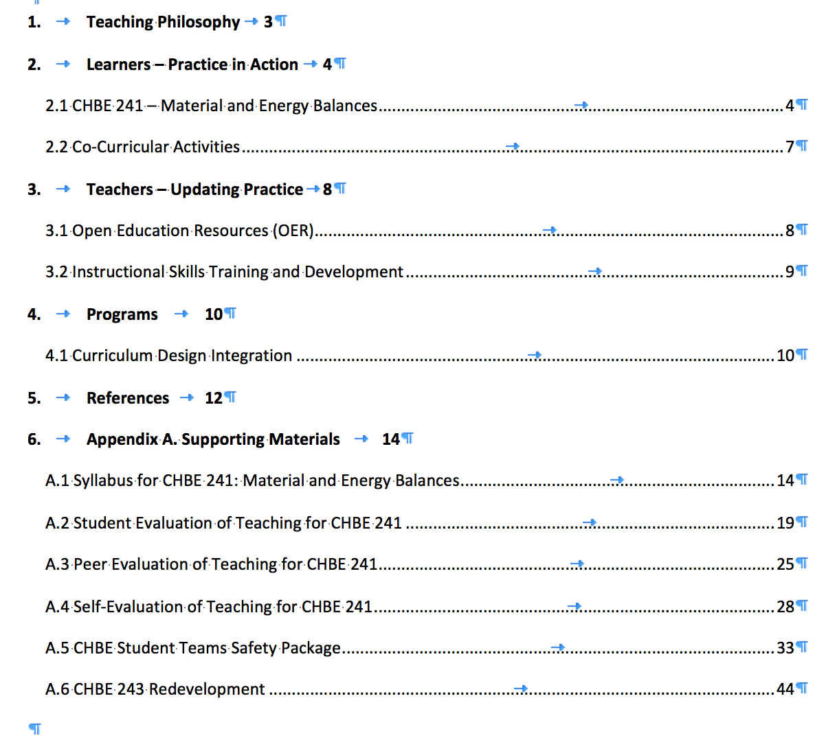

Steven Barnes
Submitted for tenure and promotion to Senior Instructor September 2017

Evidence of Teaching Effectiveness Part 1 (# of pages in parenthesis)
- Statement of Teaching Philosophy (3)
- Summary of Teaching Highlights at UBC (1)
- Summary of Teaching Duties and Course Evaluations Since Appointment
- to Instructor (1)
- Figure 1: Average UMI 6 Ratings for Each Academic Year Since Appointment to Instructor (1)
- Areas of Focus for Continued Improvement (1)
- Student Comments from Six Courses (21)
- Student Nominations for the Knox Master Teacher Award (26)

Evidence of Educational Leadership Part 2
- Statement of Educational Leadership and Teaching Innovation (3)
- Statement of Curriculum and Course Development (2)
- Undergraduate Program Renewal: New Specialization Objectives and Learning Goals

Service Part 3
- Statement of Service (1)

Appendices
- Appendix A: Sample Course Syllabi
- Appendix B: Sample Exams
- Appendix C: Sample Lecture Slides
- Appendix D: Examples of Student Projects
- Appendix E: Large TLEF LOI for 2017-18 Round of Applications
- Appendix F: New Undergraduate Program
- Appendix G:Video Production
- Appendix H: Animation Production

Ives, Joss
Submitted SEPTEMBER 9, 2017 for Tenure and Promotion to Senior Instructor
Contents
1. Statement of Teaching Philosophy ........................................................................................................ 3
2. Teaching Activities ................................................................................................................................. 5
2.1. Teaching evaluation summary ............................................................................................................ 6
2.2. Vantage One Science: Introductory Physics Sequence (Physics 117/118) .......................................... 8
2.3. Introductory Physics Lab Sequence (Physics 107 lab/109/119) ........................................................ 20
2.4. Teaching Techniques in Physics and Astronomy (Physics 520) ......................................................... 24
2.5. Energy and Waves (Physics 101) ....................................................................................................... 25
2.6. First-Year Seminar in Science (SCIE 113) ........................................................................................... 26
2.7. Jump Start Faculty Fellow ................................................................................................................. 28
3. Education Leadership .......................................................................................................................... 29
3.1. Participation in and contributions to the Physics Education Research community ......................... 29
3.2. Enhancement of my local education communities ........................................................................... 31
3.3. Leadership in the innovation and implementation of evidence-based instructional strategies ….... 32
3.4. Capacity building for excellence in education ................................................................................... 33
4. Professional Development ................................................................................................................... 34
Appendices .............................................................................................................................................. 35
Appendix 1: Sample Materials for Vantage One Science: Introductory Physics Sequence. .................... 35
Appendix 2: Sample Materials for PHYS107 Lab, PHYS119 & PHYS109 ................................................ 100
Appendix 3: Sample Materials for PHYS 520 ......................................................................................... 122
Appendix 4: Sample Materials for PHYS 101 ......................................................................................... 124
Appendix 5: Sample Materials for SCIE 113 ........................................................................................... 155

Sally Willis-Stewart
Sr. Instructor, School of Health and Exercise Sciences
Submitted for review for promotion to Professor of Teaching, September 2017
Educational Leadership and Scholarly Teaching Dossier
Faculty of Health and Social Development

Page:
Introduction Statement 4

Section 1: Educational Leadership and Scholarship of Teaching and Learning (SoTL) 4
- Focus and Objectives 4
- Student Wellbeing and Learning Initiatives 6
i. UBC Wellbeing Initiative 6
ii. First Year Health Course (SoTL) 7
iii. Nutrition Education Center 9
iv. Exercise Breaks in the Classroom (SoTL) 12
v. Take a Stand Policy 14
vi. Study Smart (SoTL) 15
vii. Caring Campaign 15
viii. Got Health? Research (SoTL) 15
- Curriculum Development 16
- Undergraduate Program Coordinator 18
- B. C. Physical Education and Kinesiology Articulation Committee 22
f. Instructor Network Leadership Team 25
g. International Certificate for the Scholarship of Educational Leadership in Higher Education 26
h. Faculty and Graduate Student Mentoring 27
i. Center for Teaching and Learning Involvement 28

Section 2: Teaching 29
- Teaching Philosophy 29
- Courses Taught 30
- Teaching Innovation Practices 31
- Awards 35
- Continuing Education 35
Section 3: Service 38
- Faculty of Health and Social Development Service 38
- Campus Service 39
- Professional Service 39
- Community Service 40
Section 4: Dissemination and Impact 41
a. International Impact 41
b. National Impact 42
c. Provincial Impact 43
d. Community Impact 44
e. University Impact 44
f. Classroom Impact 46
Section 5: Summary Statement and Future Goals 47
Section 6: Appendices 48
- Curriculum Vitae 48
- Peer Reviews of Teaching 67
- Teaching Evaluation Questionnaire Summaries 67
- Have you filled a bucket today? 73

“. . . .promotion to the rank of Professor of Teaching requires. . . . evidence of outstanding achievement in teaching and educational leadership in the field of teaching and learning, sustained and innovative contribution to curriculum development, course design and other initiatives that advance the university’s ability to excel in its teaching and learning mandate. (Art. 3.05).

Candidates will also be assessed on their service to the academic profession, the department, the university and the community. (Art. 4.01, 4.04)”

“. . . . educational leadership is activity taken at UBC and elsewhere to advance
innovation in teaching and learning with impact beyond one’s classroom.” (Sec. 3.4)

Excerpts from the UBC Senior Appointments Committee Guidelines for Promotion and Tenure, 2016 - 2017

Siobhàn McPhee
Submitted for tenure and promotion to Senior Instructor

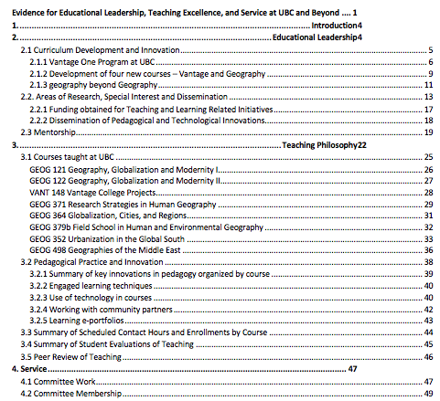

Continued on next page

Siobhàn McPhee Table of Contents continued

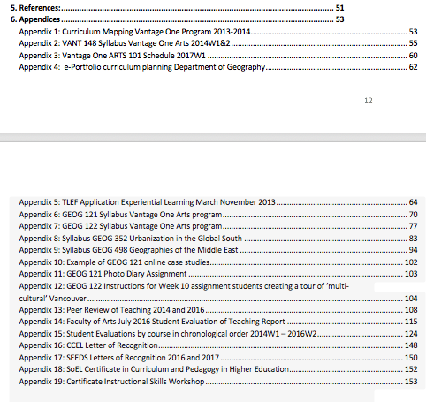

Catherine Rawn
Submitted for Tenure and Promotion to Senior Instructor September 2014
[Note for this Guidelines document: “References” refers to works cited/bibliography, not to referees]
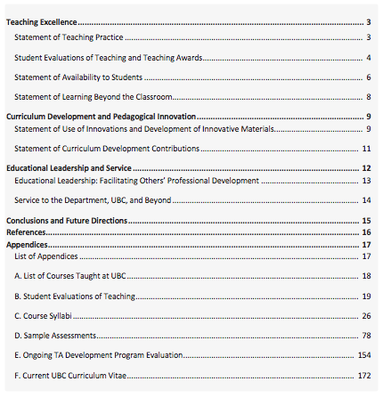

Catherine Rawn
Submitted for Promotion to Professor of Teaching July 2018 [Note for this Guidelines document: “References” refers to works cited/bibliography, not to referees]
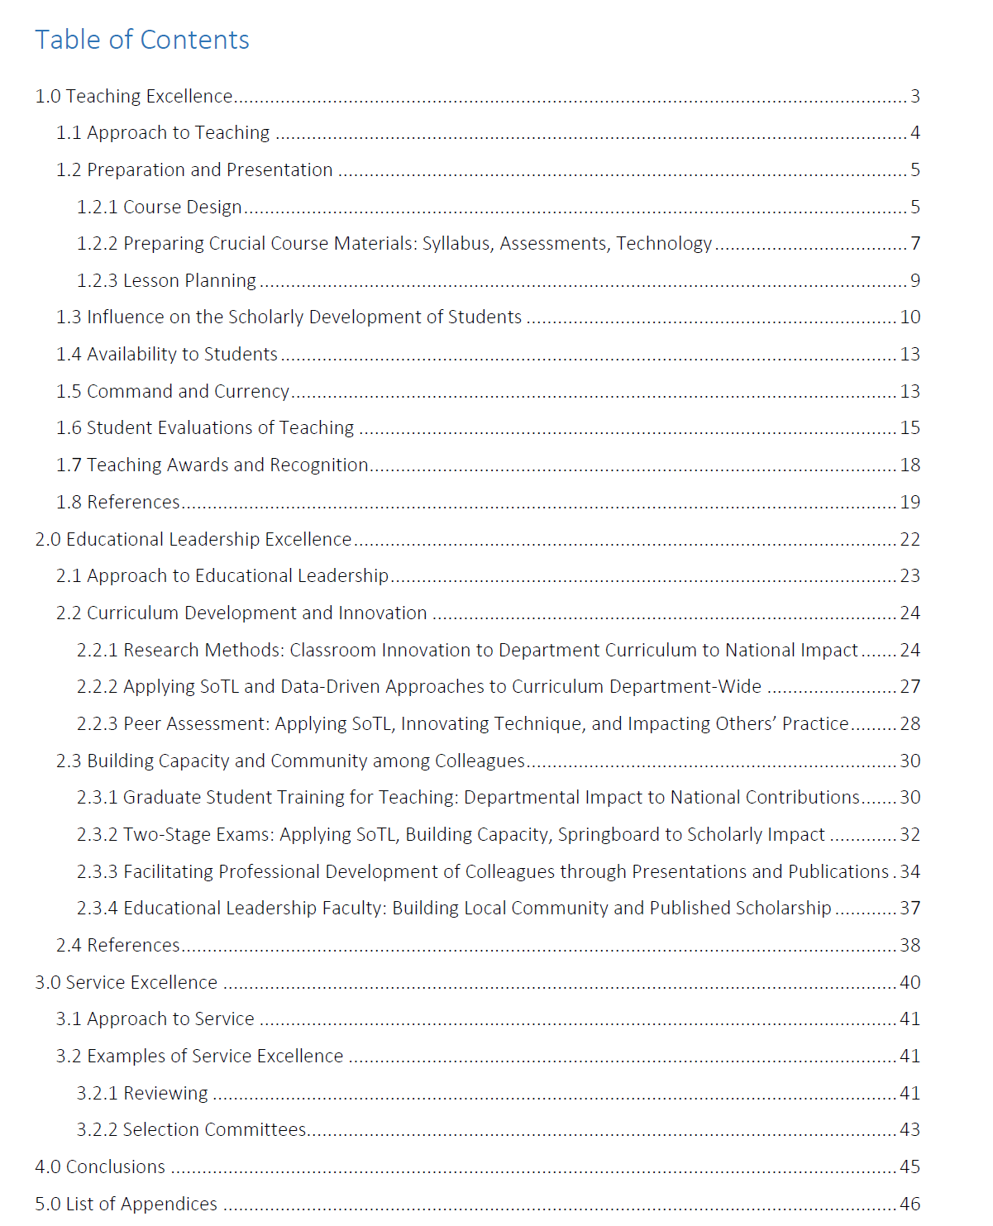
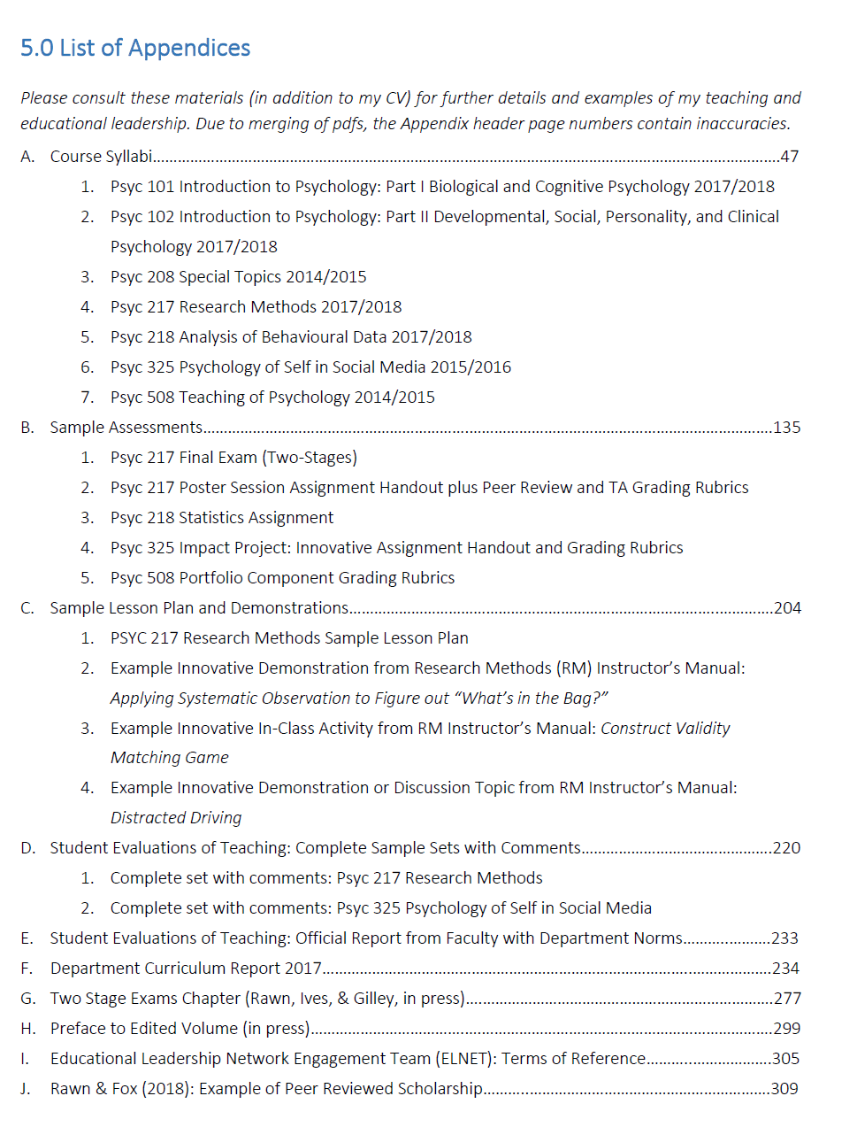

Christina Hendricks
For promotion to Professor of Teaching

Teaching and Educational Leadership Dossier (2015)
Teaching | p. 2
A list of the courses I've taught, to provide context for the rest of the materials in this section | p. 3
A scholarly teaching statement, that describes many aspects of my approach to teaching and grounds them in the research literature on teaching and learning | p. 5
A list of the workshops and courses I've taken as professional development for my teaching practice | p. 17
A report on my student evaluations over the last five years  A recent summative peer review of teaching (Fall 2014) | p. 20  p. 34
Educational Leadership | p. 37
A brief overview of my educational leadership activities | p. 39
My work in the Scholarship of Teaching and Learning | p. 40
My work in Open Education | p. 43
The teaching and learning workshops and courses I have facilitated | p. 50
Curriculum development | p. 53
Arts One Chair | p. 56
My publications, presentations, and grants related to teaching and learning | p. 59
Service  Appendices | p. 64  p. 67
Appendices
- Sample course materials (p. 2)

  - Guidelines for writing essays, for Philosophy courses
  - Essay marking rubric I use in all my courses
  - Sample peer feedback worksheet students use to comment on each other’s essays
  - PHIL 102, Introduction to Philosophy (value theory)
    - syllabi: Spring 2010, Fall 2013, Summer 2015
    - assignments: scaffolded essays, blog posts, “philosophy in the world”
  - PHIL 230, Introduction to Moral Theory
    - syllabi: Summer 2009, Fall 2014
    - assignments: moral issue journal, essay assignment, group presentations
  - PHIL 449, Continental Philosophy Seminar
    - syllabi: Spring 2012, Spring 2014
    - assignments: non-traditional artifacts, research paper
  - Arts One
    - syllabi: 2010-2011, 2014-2015
    - assignments: blog posts, self-assessment of essays, student presentations

- Student evaluations reports (p. 110)
  - PHIL 102, Fall 2013 & Summer 2015
  - PHIL 230, Summer 2009 and Fall 2014
  - Arts One, all lecture and seminar evaluations 2009-2015
  - Arts One, unofficial, anonymous, post-course survey in Spring 2014

- Award applications and recommendation letters (p. 150)

Sara Harris
(“submitted September 2014 for Promotion to Professor of Teaching, and which, on looking at it now, seems way too long” – SH) See next page

David Ng
(Submitted July 2017 for promotion to Professor of Teaching)

David Ng, Ph.D.

Director and Senior Instructor, Advanced Molecular Biology Laboratory,
Michael Smith Laboratories, University of British Columbia, Vancouver Campus.

2185 East Mall, Vancouver, BC, Canada, V6T 1Z4
Phone 604-822-6264
db@mail.ubc.ca | twitter: @ng_dave
web: (work) http://bioteach.ubc.ca | (personal/portfolio) http://thisishowitalkscience.tumblr.com

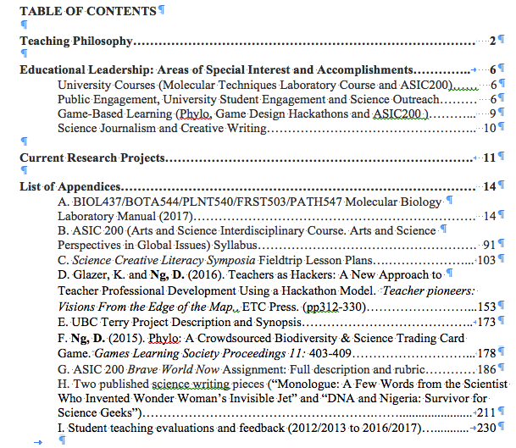
Sources of Information for this Document

The information in this document comes from three key sources:
A. Email responses to two questions
In the spring of 2018, The ELNET (Educational Leadership Network Engagement Team) and some other EL faculty were asked to respond via email to two key questions:
- What deliberate choice(s) have you made when creating your UBC-CV and/or teaching dossier? The goal here is to collectively generate some good practice tips and suggestions. For example, in my CV I add a 1-2 sentence brief annotation to explain roles that might be unfamiliar or highly variable (e.g., what I actually did to contribute to a committee).
- How does your CV fit in with your Dossier? How do you see the two documents working together, if at all, to make your case?
Respondents were also invited to attach the table of contents for their dossier and indicate whether they would agree to share this with others.
B. In-person EL Network event
On May 30, 2018, members of the EL Network were invited to an event titled “Sharing Ideas, Tips, and Strategies for Preparing EL CVs and Dossiers”.
That event included small group discussions among participants in which they shared strategies and noted questions they have regarding the preparation of their CV and dossier. There was also a brief presentation led by Simon Bates.
Recording of that event can be found here: https://youtu.be/-j-ZhOMZvVA
C. Results from follow-up meetings in August 2018 the Chair of SAC (Margot Filipenko, with Catherine Rawn and Christina Hendricks) and in September 2018 with members of Faculty Relations (with Catherine Rawn, Silvia Bartolic and Jonathan Verrett). Catherine Rawn then distilled the collected advice into this briefer document (October 2018). Final comments from Christina Hendricks were incorporated.

Contributors

Jonathan Verrett (Instructor, Department of Chemical and Biological Engineering, Faculty of Applied Science, jonathan.verrett@ubc.ca)
Steven Barnes (Instructor, Department of Psychology, Faculty of Arts, sjb@psych.ubc.ca)
Joss Ives (Senior Instructor, Department of Physics and Astronomy, Faculty of Science, joss@phas.ubc.ca)
Sally Willis-Stewart (Senior Instructor, Undergraduate Coordinator, Director Nutrition Education Centre, School of Health and Exercise Sciences, UBC-O, sally.willis-stewart@ubc.ca)
Siobhán McPhee (Instructor, Department of Geography and UBC Vantage One Program, Faculty of Arts, siobhan.mcphee@geog.ubc.ca)
Catherine Rawn (Professor of Teaching; start date July 2009, tenured 2014, promoted 2019; Department of Psychology, Faculty of Arts, cdrawn@psych.ubc.ca)
Christina Hendricks (Professor of Teaching, Department of Philosophy, Faculty of Arts, christina.hendricks@ubc.ca)
Sara Harris (Professor of Teaching, Department of Earth, Ocean, and Atmospheric Science; and Associate Dean Academic, Faculty of Science, sharris@eaos.ubc.ca)
David Ng (Senior Instructor, Michael Smith Laboratories, Faculty of Science, db@mail.ubc.ca)

